Chapter 8, Solution 49.

Determine i(t) for t > 0 in the circuit of Fig. 8.96.

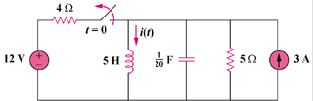

Figure 8.96
For Prob. 8.49.

Solution

For t = 0⁻, i(0) = 3 + 12/4 = 6 and v(0) = 0.

For t > 0, we have a parallel RLC circuit with a step input.

- = 1/(2RC) = (1)/(2x5x0.05) = 2

ω_{o} = 1/ = 1/ = 2

Since α = ω_{o}, we have a critically damped response.

s_{1,2} = -2

Thus, i(t) = I_{s} + [(A + Bt)e^{-2t}], I_{s} = 3

i(0) = 6 = 3 + A or A = 3

v = Ldi/dt or v/L = di/dt = [Be^{-2t}] + [-2(A + Bt)e^{-2t}]

v(0)/L = 0 = di(0)/dt = B – 2x3 or B = 6

Thus, i(t) = {3 + [(3 + 6t)e^{-2t}]} A

